**PATIENT VISIT DATA ANALYSIS PROJECT**

### **Project Overview:**

Analysing Patients Visit Data For A Hospital To Gain Insights And Enhance Decision-Making.

### 

### **Project Objective:**

Generate A Improved Dynamic Dashboard’s For Patient Visits To Analyze And Visualize Hospital patient Data.

### **Project Requirements:**

* Problem Statement
* Data Source
* Software’s Required

**Problem Statements:**

1. Evaluate The average Waiting Time Of patient
2. Patient Visit On a Monthly And Year Basis
3. Total Visit By Department Referral
4. Breakdown Patients Visit By age Group
5. Determine The Average Satisfaction by Age-Group And Patient Race
6. Determine The Average Wait Time by Age-Group And Patient Race
7. Patient Visit According To Gender
8. Determine Average Visits Per Month And seasonal Index

**Data Source:**

Utilizing Patient Data Collected By Hospital Management For Comprehensive Data Analysis.

Data Collection Tool : MS excel

**Software’s Used:**

OS Tool : ChatGPT

BI Tool : Microsoft Power BI

### **Project Process:**

**Step By Step Process:**

1. Collecting the Data set
2. Importing Data set Into Power Bi
3. Data Transform And Cleaning
4. Data Processing(DAX)
5. Data Visualization
6. Final Dash Board

**1.Collecting Data**

The Data set collected From Hospital Management In The Form Of Excel Sheets.

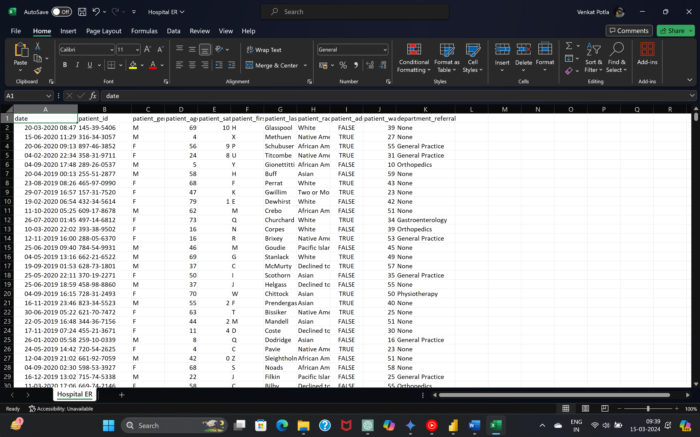

**2.Importing Data set Into Microsoft Power BI**

* For That, Open Power BI, Go to Get Data and Select Text/CSV Then, Make a Connection With CSV File

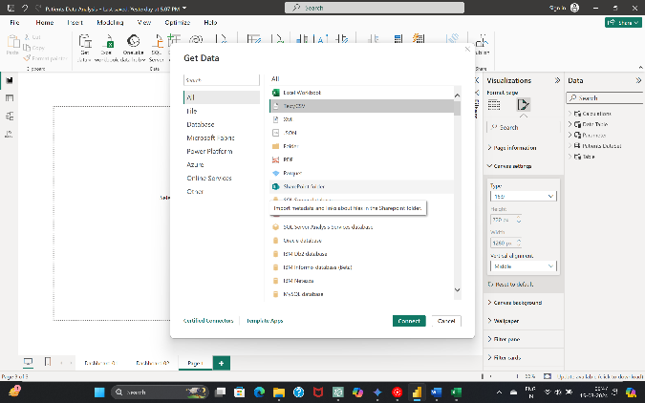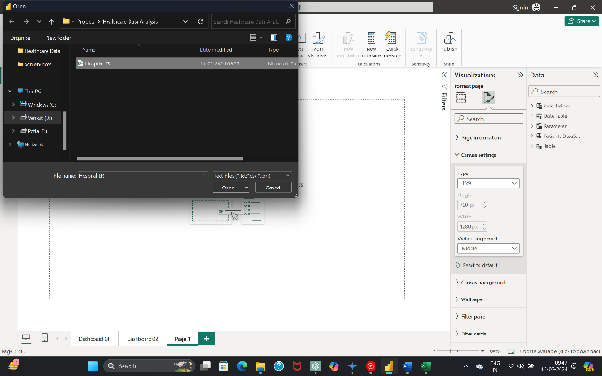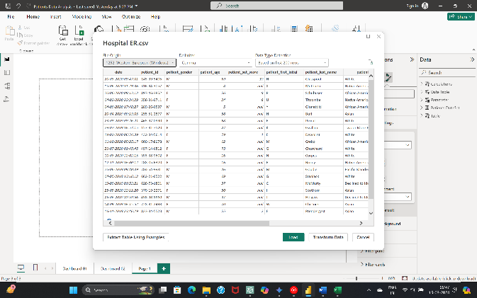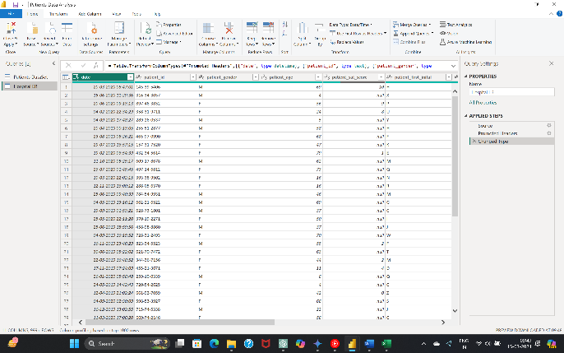

* After Completion of Connection we can Load Or Transform Data Based On Requirement

**6.Data Cleaning &Processing**

* After Loading Data Into PowerBI By Using The Power Query Editor, We Perform DAX(Data Analysis Express) For Data cleaning and Processing
* These Are Some Of DAX Formulas written for Data Visualization

**DAX Formula’s:**

**1.Date Table**

Date Table = ADDCOLUMNS(CALENDAR(MIN('Patients DataSet'[Date]),MAX('Patients DataSet'[Date])),"Year",YEAR([Date]),"Month",FORMAT([Date],"mmm"),"WeekNumber",WEEKDAY([Date]),"weekType", IF(WEEKDAY([Date])=1,"Weekend",IF(WEEKDAY([Date])=7,"Weekend","Weekday")),"Weekday",FORMAT([Date],"ddd"),"Month Number",MONTH([Date]))

**2.Patient Visit Data table**

1. Total Patients = COUNT('Patients DataSet'[patient_id])
2. Average Wait Time = AVERAGE('Patients DataSet'[patient_waittime])
3. Avg Satisfaction Rate = CALCULATE(AVERAGE('Patients DataSet'[patient_sat_score]),'Patients DataSet'[patient_sat_score]<>BLANK())
4. % No Rating = VAR _NoRatings=CALCULATE([Total Patients],'Patients DataSet'[patient_sat_score]=BLANK()) RETURN

DIVIDE(_NoRatings,[Total Patients])

1. % Administrative = DIVIDE(COUNTROWS(FILTER('PatientsDataSet','Patients DataSet'[patient_admin_flag]=TRUE())),[Total Patients])
2. % NON Administrative = DIVIDE(COUNTROWS(FILTER('Patients DataSet','Patients DataSet'[patient_admin_flag]=FALSE())),[Total Patients])
3. % Female Visit = DIVIDE(CALCULATE([Total Patients],'Patients DataSet'[patient_gender]="F"),[Total Patients])
4. % Male Visit = DIVIDE(CALCULATE([Total Patients],'Patients DataSet'[patient_gender]="M"),[Total Patients])
5. % Unknown = DIVIDE(CALCULATE([Total Patients],'PatientsDataSet'[patient_gender]="NC"),[Total Patients])
6. % Referred Patient = VAR _FilterPatients= CALCULATE([Total Patients],'Patients DataSet'[department_referral]<> "none") RETURN DIVIDE(_FilterPatients,[Total Patients])
7. % Un Referred Patient = VAR _FilterPatients= CALCULATE([Total Patients],'Patients DataSet'[department_referral]="none") RETURN DIVIDE(_FilterPatients,[Total Patients])
8. Age Buckets = SWITCH(TRUE(),'Patients DataSet'[patient_age]<=10, "0-10",'Patients DataSet'[patient_age]<=20, "11-20",'Patients DataSet'[patient_age]<=30, "21-30",'Patients DataSet'[patient_age]<=40, "31-40",'Patients DataSet'[patient_age]<=50, "41-50",'Patients DataSet'[patient_age]<=60, "51-60",'Patients DataSet'[patient_age]<=70, "61-70","70+")
9. Age Group = VAR _patientAge = 'Patients DataSet'[patient_age] RETURN IF(_patientAge<2,"infancy",IF(_patientAge<6,"Early Childhood",IF(_patientAge<12,"Middle Childhood",IF(_patientAge<18,"Teenager","Adult"))))
10. CF Marks Point(month) = VAR _Patient_table= CALCULATETABLE( ADDCOLUMNS(SUMMARIZE('Date Table','Date Table'[Month]),"@TotalPatients",[Total Patients] ),ALLSELECTED())

VAR _Minvalu =MINX(_Patient_table,[@TotalPatients]) VAR _Maxvalu =MAXX(_Patient_table,[@TotalPatients])

VAR _Totalpatients =[Total Patients] RETURN SWITCH(TRUE(),

_Totalpatients=_Minvalu,0,_Totalpatients=_Maxvalu,1)

1. CF Marks Point(Year) = VAR _Patient_table=CALCULATETABLE(ADDCOLUMNS(SUMMARIZE('Date Table','Date Table'[Year]), "@TotalPatients",[Total Patients] ),ALLSELECTED())

VAR _Minvalu =MINX(_Patient_table,[@TotalPatients])

VAR _Maxvalu =MAXX(_Patient_table,[@TotalPatients])

VAR _Totalpatients =[Total Patients]

RETURN

SWITCH(TRUE(), _Totalpatients=_Minvalu,0, _Totalpatients=_Maxvalu,1)

1. Hitmap Caption = VAR _selectMeasure = SELECTEDVALUE(Parameter[Parameter Order])

RETURN IF(_selectMeasure =1,

"The Darkest Colour On Scale Denotes High Wait Time On Age_group","Patients Are Most Statifed When Scale Shows The darkest Colour On The Age_Group")

1. Hour = HOUR('Patients DataSet'[Time])
2. AvgVisitsPerMonth = DIVIDE([Total Patients], COUNTROWS(DATESYTD('Patients DataSet'[Date])))
3. SeasonalIndex = [Total Patients] / [AvgVisitsPerMonth]
4. Parameter = { ("Avg Wait Time", NAMEOF('Patients DataSet'[Avearge Wait Time]), 1),

("Avg Statisfaction Rate", NAMEOF('Patients DataSet'[Avg Statisfaction Rate]), 0)}

1. Value Marks Point(month) = VAR _Patient_table=

CALCULATETABLE(ADDCOLUMNS(SUMMARIZE('Date Table','Date Table'[Month]),"@TotalPatients",[Total Patients]),

ALLSELECTED())

VAR _Minvalu =MINX(_Patient_table,[@TotalPatients])

VAR _Maxvalu =MAXX(_Patient_table,[@TotalPatients])

VAR _Totalpatients =[Total Patients]

RETURN

SWITCH(

TRUE(),_Totalpatients=_Minvalu,[Total Patients], _Totalpatients=_Maxvalu,[Total Patients])

**3.Table**

1. Table = VAR _Patient_table= CALCULATETABLE( ADDCOLUMNS( SUMMARIZE('Date Table','Date Table'[Month]),

"@TotalPatients",[Total Patients]),

ALLSELECTED()) RETURN _Patient_table

**8.Data Visualization**

* After Cleaning And Processing The Data According To The Requirements of Hospital Management, Prepare Dashboards’ For A Hospital Management To Get Insights And Improve Decision-Making

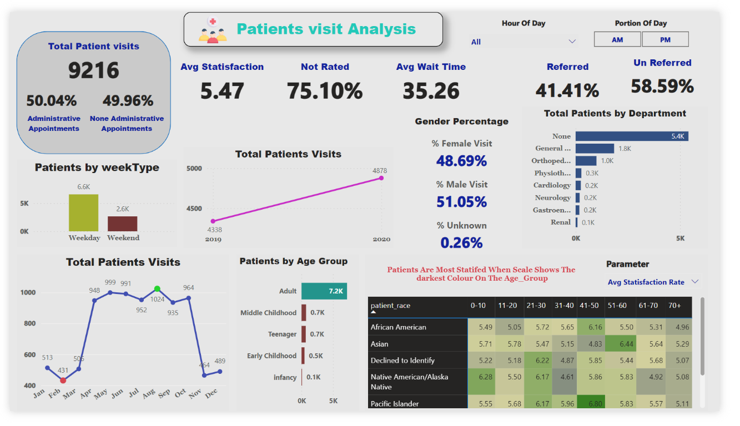

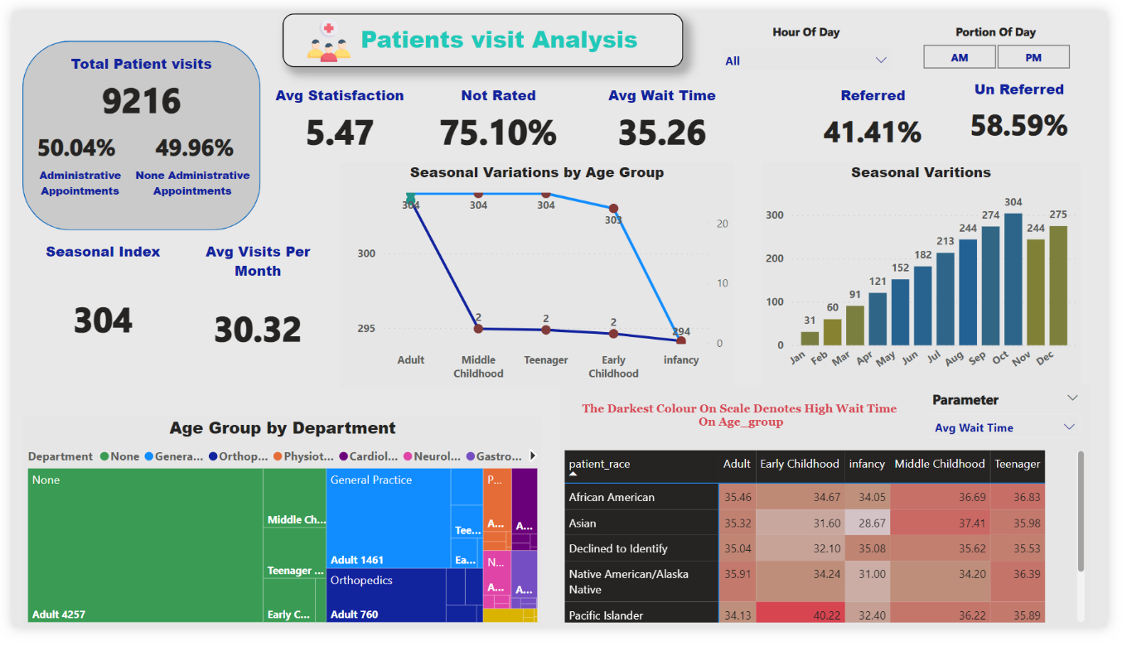

### **Conclusion:**

**Total Patient Visits**:

* **Total of 9216 patient visits**. This figure likely encompasses both administrative and non-administrative appointments.

**Satisfaction Rates**:

* The **average satisfaction rate** across all visits is **5.47**.
* Interestingly, a significant portion of patients (approximately **75.10%**) have not been rated for satisfaction.

**Wait Times:**

* The **average wait time** for patients is **35.26 minutes**.
* This metric provides valuable insights into operational efficiency and patient experience.

**Referral Rates:**

* **41.41%** of patients have been referred By Specific Department.
* Understanding referral patterns can aid in optimizing healthcare services.

**Gender Distribution**:

* The dashboard shows an **almost equal distribution** between male and female patients.
* Gender demographics play a crucial role in tailoring healthcare services.

**Age Groups**:

* **Adults** constitute the majority of visitors.
* Seasonal variations in visits by age group are evident

**Weekday Trends**:

* Most visits occur during the **weekdays**.
* Analysing daily patterns helps allocate resources effectively.

**Seasonal Variation’s:**

* There are more visits by younger age groups (Early Childhood, Infancy, Childhood) in the summer months (Jun, Jul, Aug)
* More visits by older age groups (Adult, Middle) in the winter months (Oct, Nov, Dec).